NEXT MEETING:
October 14th, 2008
HOPE YOU CAN JOIN US
Please note the revised meeting schedule below!!!
REGION IV
CHAPTER 113

SEPTEMBER 2008 http://www.charleston.ashraechapters.org

ASHRAE NEWS
The American Society of Heating, Refrigerating and Air-Conditioning Engineers, Inc.
Charleston “Gee Chee” Chapter Newsletter

Chapter Meeting
Tuesday, September 9th, 2008
Radisson Hotel
NEW MEETING SCHEDULE!!!
B.O.G. 5:00 - 5:30 p.m.
Social 1/2 Hour: 5:30 - 6:00 p.m.
Dinner/Meeting: 6:00 - 7:00 p.m.
Tech. Program: 7:00 - 8:00 p.m.

Cost: $20.00 per person
+$5 for the open bar



CHAPTER PROGRAM

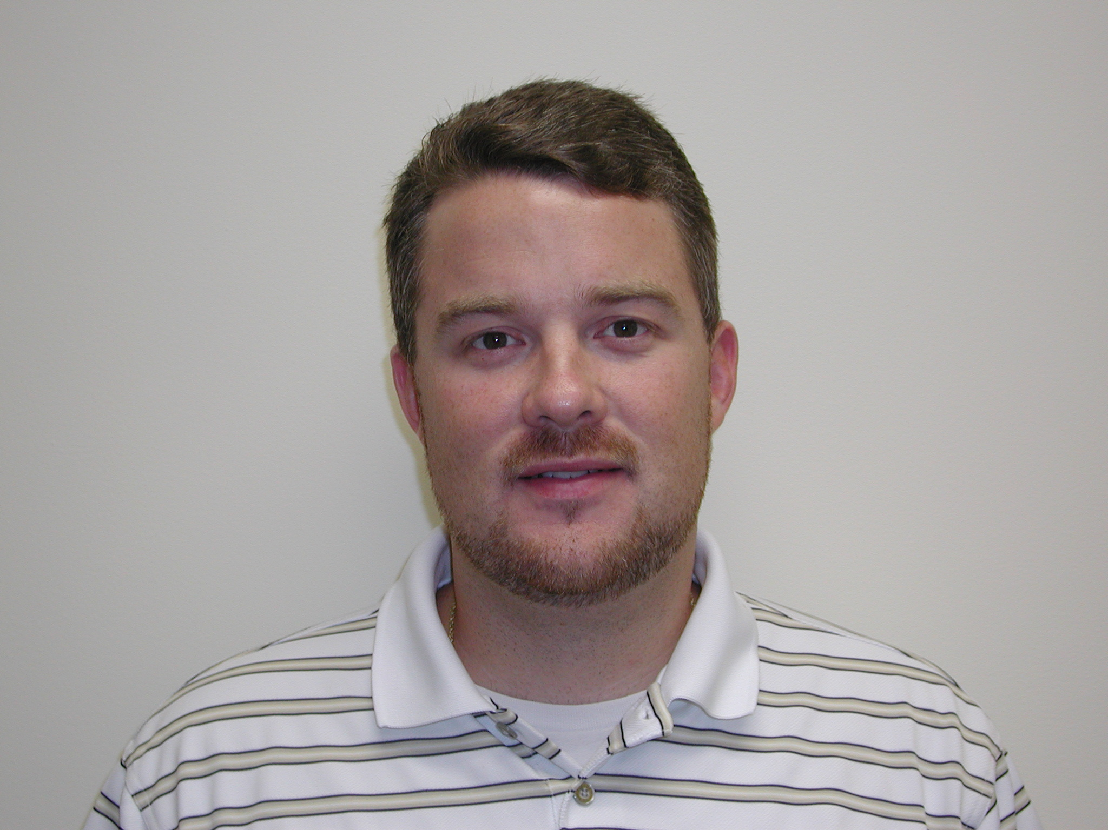
MEETING SPEAKER
JOEL DAVIS
Synergy Engineering

With the adoption of the 2006 IBC by the state of South Carolina on July 1, 2008, one of the items receiving some significant change is chapter 16 as it relates to the design of seismic and wind restraints for mechanical, electrical, and plumbing systems.

Did you know that the new code will specifically require that these restraint systems be designed by a licensed professional engineer and incorporated into the project documents for use by the inspectors, building code officials, owners, and contractors?

Continued on page 2

CHAPTER PROGRAM FROM PAGE 1

Did you know that the new factors in the wind calculations will drive wind forces higher than the associated seismic forces on roof top systems for a significant area of the State?

Did you know that the “Seismic Design Category” is getting a new identity with a face transplant and will now be called “Occupancy Category”?

Did you every really understand what an Importance Factor Ip was and where it came from?

These changes and many more as well as a refresher on the items which are staying the same will be the program this month. The program will be presented by Joel Davis, CEO, Synergy Engineering, PA.

Joel is originally from Columbia, SC, earned a degree in mechanical engineering from the University of South Carolina in 1999. Entered the HVAC business in 1992 as a helper and spent eight years learning the trade working as a mechanic, foreman, superintendent, in estimating, assistant project manager, and project manager.

Joel is a founding partner in Synergy Engineering, a design firm based in Charlotte, North Carolina dedicated to the design of seismic restraints, vibration isolation, finite element analysis, and coordination drawings.

Joel is an active member of the Southern Piedmont Chapter of ASHRAE is a past president of the Southern Piedmont Chapter of ASHRAE, and also the Pinnacle award recipient for the 2002-2003 campaign year.

Joel resides in Waxhaw, NC with his wife Aimee and four children, Allie, Tatum, Jay, and Wyatt.

LECTURE TOPIC:

SEISMIC DESIGN

The President’s Corner
Rob Turner

We had a very productive CRC at Sea Trails Resort in North Carolina. We got the following awards: Full Circle, Century Club (Dennis Knight), Presidential Award of Excellence for Sustainability, the Star Award, the Chapter Service Award (Mike Weeks), and the Goal, Challenge Goal, and High Five (Dennis Knight). Congratulations go to Randy Jones for attaining the position of Assistant Regional Chairman (ARC). As you know, Steve Marek is the Regional Vice Chair for Research Promotion (RVC-RP). As you can see, there are a lot of acronyms out there. For your convenience, a list of all these acronyms can be found on the ASHRAE website at http://www.ashrae.org/docLib/20080821_MCOManualRev080821.pdf in appendix EE. This link goes to the Manual for Chapter Operations, and has a lot of educational information about how ASHRAE and our chapter works. In other news, Alissa took a sudden but wonderful job opportunity in Raleigh and will not be able to hold the office of Secretary/Newsletter Editor. Pete has graciously and temporarily stepped in to get this newsletter out. After talking with the BOG and evaluating the best interest of the future of the Charleston ASHRAE Chapter, I am very happy to announce that Chris Sturdivant has accepted the nomination for Secretary. Chris is with RMF Engineering. RMF has won a number of ASHRAE design awards. Let's welcome him at the first meeting. Pete Conroy has some fascinating programs in store for us this year. I believe they will attract a number of new members as well as bring existing members back again and again. My goals this year are to increase membership and attendance to the meetings, be more efficient and shorten the meetings, and educate the new and existing members on the ASHRAE positions, procedures, etc.

Best Regards,
Rob Turner, P.E.
Charleston Chapter President

CTT Corner

By: Gene Brown

The CRC was great! Roy Ahlgren of James M Pleasants Co gave an excellent 3 part seminar on hydronic heating.
It is easier to route a ¾” pipe than a 12” x 12” duct.
Gravity flow hot water was used in old systems. A very large pipe was required.
Boilers which allow exhaust gas to condense transfer more of the fuel energy to the water. In the HVAC industry a unit which produces hot water for space heating is called a hot water boiler. A unit which generates steam is a steam boiler.
A flow switch must be provided to shut off the boiler if there is no water flow.
A low water cut-off must be provided to keep the boiler from operating if there is not a sufficient water level.
The BTU/HR capacity is equal to 500 x gallons per minute x change in temperature.
Excessive flow in a pipe will cause erosion of the metal. Flow should be limited so that pressure drop due to friction does not exceed 4.5 ft/100 ft length.
A rule of thumb for calculating friction for the typical job is to determine the actual length of the pipe and add 50% to allow for elbows and other fittings.
All pumps are backward curved whereas some fans are forward curved.
Pressurized water at 220 to 240 F is not unusual. Many HW boilers limit temperature to 240 F.
Ethylene glycol or propylene glycol is sometimes added to the water as antifreeze. Glycol causes air bubbles to be extremely fine and more difficult to separate. For any system an air separator is required.

The expansion tank should be connected to the system near the pump intake. This keeps the pressure constant at that point when the pump is turned on and off. A reduction in pressure at the pump intake could allow a partial vacuum to be generated behind each impeller blade. The water would evaporate and the bubbles would collapse. Although this is on a small scale, the collapse is violent and over a short period of time the impeller would be destroyed.
Mr Ahlgren recommends a tank without a bladder or diaphragm. If properly fitted and set up, this tank will not cause water to be discharged periodically with a resulting requirement for makeup water.
If there is no continued makeup water, rust will not be a problem.
If it is desired that there be very little variation of flow at different conditions, a pump with a flatter curve may be chosen.
.

ALPHABET SOUP
At the 2008 CRC, we carried out the business of ASHRAE. The BOG met several times and gathered reports from the committees on CTTC, RP, MP, Programs and History.

The region was well represented, as the conference was chaired by the DRC. Each RVC gave insightful reports on the future of the region and society as a whole….

Well, I could go on a good bit longer, but I have a feeling I lost a good many of you in the jumble of acronyms. The point is, we tend to take ASHRAE and all of its structure for granted to the point of utter confusion to anyone trying to decipher what we are saying.

So we will start with the basics, and hopefully with the knowledge of what ASHRAE is, what we do, and how we do it, we can encourage more participation and growth in our chapter. First I will introduce you to who ASHRAE is in our Region…

The Charleston Chapter (Chapter 113) is a part of Region IV, which encompasses South Carolina, North Carolina and Georgia. The Chapters Regional Conference (CRC) is a meeting of all the chapters in region
IV (total of 7 chapters), where we elect officers, and essentially conduct the business of the region. There are also very helpful programs and a few recreational activities. As a side bar, I

recommend attendance of the CRC to al members.

DRC- Director and Region Chair; Mr. Ira Poston. Ira coordinates all chapter activities in Region IV, and sits for a 3 year term. He is a voting member of the ASHRAE Board of Directors and sits on the member’s council, which is chaired by the President-Elect of ASHRAE. THE MEMBER’S COUNCIL IS THE GOVERNING BODY AND VOICE OF THE GRASS ROOTS OF ASHRAE, THE CHAPTERS!

RVC- Regional Vice Chairs. There are (5) seats here, one for each committee. They are: Research Promotion (RP), Membership (MP), Programs, History and Chapters Technology Transfer Chair (CTTC). RVCs are elected to a three year term and report to the DRC.

Chapter Officers: You should all know these folks. If not, well then I recommend attending the next Chapter Meeting to get a personal introduction!! The chapter officers conduct local business, and report to the RVCs and the DRC.

I hope this was helpful. I will continue to include articles in the newsletter covering different areas of ASHRAE and how we all can make a difference!!

ASHRAE RESEARCH INVESTORS
2008-2009:
PLEASE CONSIDER A CORPORATE SPONSORSHIP!

Platinum Level Donor: ($2,500+)

Gold Level Donors: ($1,500+)

Silver Level Donors: ($1,000+)

Bronze Level Donors: ($250+)

MEMBER NEWS

We have seen many of our local engineering firms growing their businesses and bringing new folks on board. If you have recently moved to the Charleston area and wish to transfer your membership, please contact our Membership Chair, Charles Hipp, or make the change online at www.ashrae.org

WELCOME TO CHAALSTON!!

CHAPTER OFFICERS

President – Rob Turner
Phone: 762-4242
FAX: 762-4239
rob@charlestonengineering.com

Vice President – Pete Conroy
Phone: 377-2300
FAX: 377-2301
petec@jmpco.com

Secretary – Pete Conroy
Phone: 377-2300
FAX: 377-2301
petec@jmpco.com

Treasurer – Louie Schweers
Phone: 881-4803
FAX: 881-4859
louis@glsengineering.com

!!!GET INVOLVED!!!

Contact one of our Committee Chairs, or a Chapter Officer to see how YOU can make a difference!!

CHAPTER
COMMITTEE CHAIRS

Historian Research
Dave Tomayko Dan Cartin
PH# 819-2742 PH# 744-4477
dtomayko@knology.net FAX# 747-3399

Membership Savannah Section Chair
Charles Hipp, III Brian Thorstad
PH# 367-2404 PH# (912) 965-0313
FAX# Fax# (912) 355-7807

Membership Vice Chair Myrtle Beach Section
Barrett Williams Doug Law
PH# 881-3201 PH# (843) 232-0408
FAX# 881-3628 FAX# (843) 232-0508

Refrigeration Newsletter Editor
Scott Peak Pete Conroy
PH# 881-8282 PH# 377-2300
FAX# 881-8290 FAX# 377-2301

TEGA/CTT Homepage Webmaster
Eugene G. Brown, Jr. Tim Walker

PH# 963-4983 PH# 553-5513
FAX# 963-4993 FAX# 824-0501

Student Activities Student Act. Vice-Chair
Carl McGartlin Dr. Emad Afifi
PH# 406-0035 PH# (912) 525-6876
FAX# 406-0035

Programs Honors & Awards Chair
Pete Conroy Bo Nutting
PH# 377-2300 PH# 745-6748
FAX# 377-2301 FAX# 744-5553

BOARD OF GOVERNORS

Ron Runyon
Randy Jones
Phil Garces

June MEETING MINUTES
Minutes from June Meeting:

A. Chapter Officer Reports:

- President (P. Garces) – Induction of Chapter Officers
- Vice President (R. Turner) – No Report
- Secretary (P. Conroy) – No Report
- Treasurer (L. Schweers) – No Report
- Region Report (Ira Poston) – No Report

    - Chapter Chair Reports:
- Membership (C. Hipp) – No Report
- Student Activities (C. McGartlin) – No Report
- Chapter Programs (R. Turner) –No Report
- Historian (D. Tomayko) – No Report
- Refrigeration (R. Turner) - No report.
- Research (D. Knight) – No Report
- TEGA (G. Brown) – No Report
- Honors & Awards (B. Nutting) – No report

C. Old Business: Nothing to report.

  - New Business: Induction of 2008-2009 Chapter Officers.

The Charleston Chapter Wall of Honor
($100 or more individual donation)

Much of ASHRAE Research funding comes in through individual donations, so please give. We are supporting the
Charleston Chapter Wall of Honor again this year.

Can we put your name here?
’08-‘09 HONOR ROLL DONORS

THANKS FOR YOUR SUPPORT OF ASHRAE AND ITS RESEARCH PROGRAMS!

CHARLESTON CHAPTER ANNUAL PROGRAMS 2007- 2008

September
Tuesday, September 9th
Program Speaker- Joel Davis, P.E.
Changes in Seismic Design Codes

October
Tuesday, October 14th
Program Speaker- Bill Eisele, CEM.
Utility Rates and new generation oppritunities

November
Tuesday, November 11th
*PROGRAM TBD
Student Activities Emphasis Night!

December
Tuesday, December 9th
*Program TBD
Donor Recognition Night

January
Tuesday, January 13th
*Program TBD

February
Tuesday, February 10th
National Engineers Week Banquet
At the Citadel Alumni Center

March
Tuesday, March 10th
*Program TBD
Research Promotion Night!

April
Tuesday, April 14th
*Program TBD
Chapter History Night!

May
Tuesday, May 12th
*Program TBD
Student Activities Emphasis Night!

June
DATE AND LOCATION TBD
CHAPTER SOCIAL

